1. **Join**

**Problem:** The company wants to send out invitations to all employees whose job tittle ends in the word “ASSOCIATE” for a training which help them will become more efficient and productive.

SELECT A.emp_num, emp_lname, emp_email, emp_title, dept_name

FROM CH07_LargeCo_lgemployee A JOIN CH07_LargeCo_lgdepartment B ON A.dept_num=B.dept_num

WHERE emp_title LIKE '%ASSOCIATE'

ORDER BY dept_name, emp_title;

Screenshot of output:

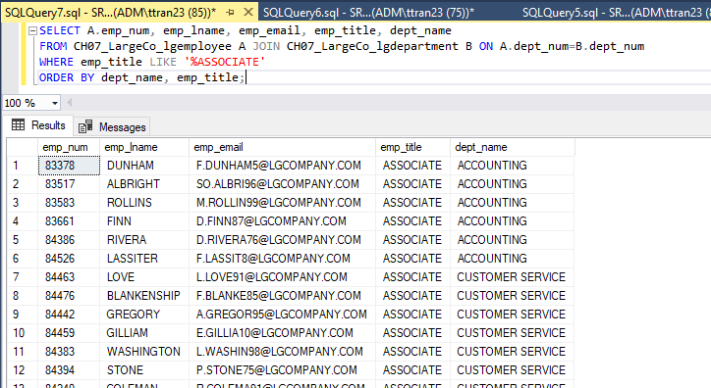

**Problem:** Darell Hagan was not happy with his experience in the store with one of our staff so he wanted to get refund and wanted to meet our manager. So, the company wants to know what happened at that time, they want to talk with the manager and the employee.

SELECT A.emp_fname AS MANAGER_FNAME, A.emp_lname AS MANAGER_LNAME, B.dept_name, B.dept_phone,

C.emp_fname AS EMPLOYEE_FNAME, C.emp_lname AS EMPLOYEE_LNAME, E.cust_fname AS CUSTOMER_FNAME,

E.cust_lname as CUSTOMER_LANME, D.inv_date, D.inv_total AS INV_TOTAL

FROM [CH07_LargeCo_lgemployee] A, [CH07_LargeCo_lgdepartment] B,

[CH07_LargeCo_lgemployee] C, [CH07_LargeCo_lginvoice] D, [CH07_LargeCo_lgcustomer] E

WHERE B.emp_num = A.emp_num

AND C.emp_num=D.employee_id

AND B.dept_num=C.dept_num

AND D.cust_code=E.cust_code

AND E.cust_lname = 'Hagan'

AND D.inv_date = '05-18-2017';

Screenshot of output:

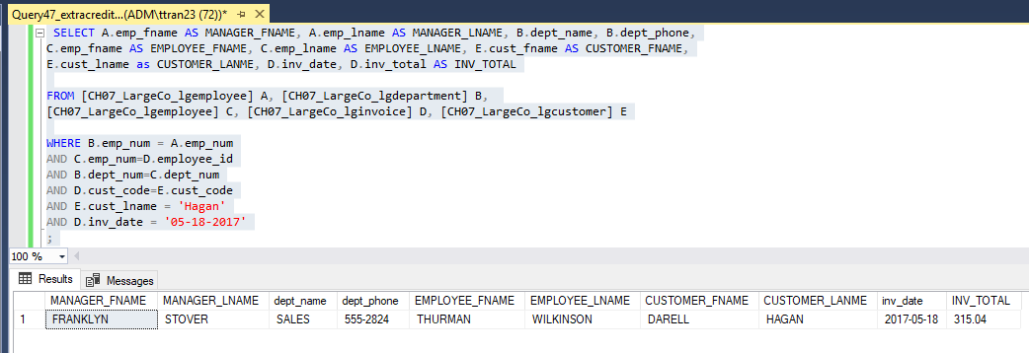

1. **Subquery**

**Problem:** The purchasing manager is still concerned about the impact of price on sales.

select A.brand_name, A.brand_type, B.prod_sku, B.prod_descript, B.prod_price

from CH07_LargeCo_lgbrand A, CH07_LargeCo_lgproduct B

where A.brand_id=B.brand_id

and A.brand_type not like '%PREMIUM%'

and B.prod_price > (select max(D.prod_price)

from CH07_LargeCo_lgbrand C, CH07_LargeCo_lgproduct D

where C.brand_id=D.brand_id

and C.brand_type = 'PREMIUM') ;

Screenshot of output:

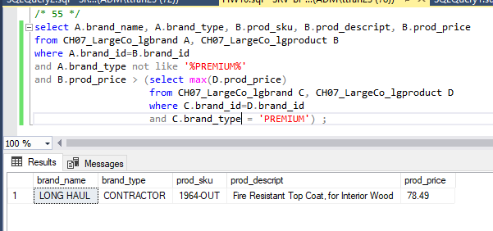

**Problem:** The Binder Prime Company wants to recognize the employee who sold the most of

its products during a specified period between November 1, 2017, and December 5, 2017.

SELECT emp.emp_num, emp_fname, emp_lname, emp_email, total

FROM CH07_LargeCo_lgemployee AS emp INNER JOIN

(SELECT employee_id, sum(line_qty) AS total

FROM CH07_LargeCo_lginvoice AS i INNER JOIN CH07_LargeCo_lgline as l ON i.inv_num = l.inv_num

INNER JOIN CH07_LargeCo_lgproduct AS p ON l.prod_sku = p.prod_sku

INNER JOIN CH07_LargeCo_lgbrand AS b ON b.brand_id = p.brand_id

WHERE brand_name = 'Binder Prime'

AND inv_date BETWEEN '2017-11-01' AND '2017-12-06'

GROUP BY employee_id) AS sub

ON emp.emp_num = sub.employee_id

WHERE total = (SELECT max(total)

FROM (SELECT employee_id, sum(line_qty) AS total

FROM CH07_LargeCo_lginvoice AS i INNER JOIN CH07_LargeCo_lgline as l ON i.inv_num = l.inv_num

INNER JOIN CH07_LargeCo_lgproduct AS p ON l.prod_sku = p.prod_sku

INNER JOIN CH07_LargeCo_lgbrand AS b ON b.brand_id = p.brand_id

WHERE brand_name = 'Binder Prime'

AND inv_date BETWEEN '2017-11-01' AND '2017-12-06'

GROUP BY employee_id) as sub1)

ORDER BY emp.emp_lname;

Screenshot of output:

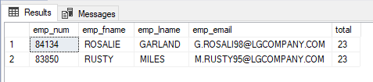

1. **Subquery with Union**

**Problem:** The company is planning a new promotion in Alabama (AL) and wants to know about

the largest purchases made by customers in that state. Even with some customers in AL have not bought anything from our store.

select A.cust_code, A.cust_fname, A.cust_lname, A.cust_street, A.cust_city, A.cust_state, A.cust_zip, B.inv_date, B.inv_total as 'Largest Invoice'

from CH07_LargeCo_lgcustomer A, CH07_LargeCo_lginvoice B

where A.cust_code=B.cust_code

and A.cust_state = 'AL'

and B.inv_total= (select max(C.inv_total) from CH07_LargeCo_lginvoice C

where C.cust_code=A.cust_code)

union

select A2.cust_code, A2.cust_fname, A2.cust_lname, A2.cust_street, A2.cust_city, A2.cust_state, A2.cust_zip, Null, 0

from CH07_LargeCo_lgcustomer A2

where A2.cust_state = 'AL'

and A2.cust_code not in (select B2.cust_code from CH07_LargeCo_lginvoice B2)

order by A.cust_lname, A.cust_fname;

Screenshot of output:

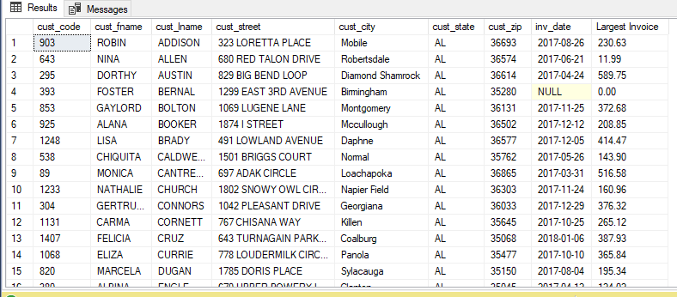

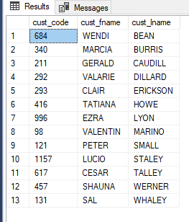**Problem:** The company want to check new employees’ productivity, who has ID: 83649 and 83677.

select distinct X.cust_code, X.cust_fname, X.cust_lname

from

(select A.cust_code, A.cust_fname, A.cust_lname

from CH07_LargeCo_lgcustomer A, CH07_LargeCo_lginvoice B

where A.cust_code=B.cust_code

and B.employee_id = 83649) as X,

(select C.cust_code, C.cust_fname, C.cust_lname

from CH07_LargeCo_lgcustomer C, CH07_LargeCo_lginvoice D

where C.cust_code=D.cust_code

and D.employee_id = 83677) as Y

where X.cust_code=Y.cust_code

order by X.cust_lname, X.cust_fname;

Screenshot of output:

1. **Creating table, Altering table**

CREATE TABLE CUSTOMER (

CUST_NUM INTEGER PRIMARY KEY,

CUST_LNAME VARCHAR(30),

CUST_FNAME VARCHAR(30),

CUST_BALANCE DECIMAL(8,2));

INSERT INTO CUSTOMER VALUES ('1000', 'Smith', 'Jeanne', '1050.11');

INSERT INTO CUSTOMER VALUES ('1001', 'Orlega', 'Juan', '840.92');

ALTER TABLE CUSTOMER

ADD CUST_DOB DATE;

UPDATE CUSTOMER

SET CUST_DOB = 'March 15,1989'

WHERE CUST_NUM = 1000;

UPDATE CUSTOMER

SET CUST_DOB = 'December 22,1988'

WHERE CUST_NUM = 1001;

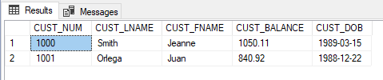

**Problem:** write the SQL command to add .15 to the EMP_PCT of the employee whose name is Maria D. Alonzo.

UPDATE EMP_3

SET EMP_PCT = (EMP_PCT + 0.15)

WHERE EMP_LNAME='Alonzo',EMP_FNAME='Maria', EMP_INITIAL='D' ;

